# INVENTORY MANAGEMENT SYSTEM FOR RETAILERS

TEAM ID : **PNT2022TMID19193**

TEAM MEMBERS : **Danush P S,Praveen Babu R, Shalinisri J, Kavipriyaa P**

**1. INTRODUCTION**

* 1. **PROJECT OVERVIEW**

The majority of organisations still operate on a manual system that requires employees to record data by hand. This could occasionally result in a situation where the employee forgot to update the stock, wasting time while they wait for stock orders.once a need arises. Another issue with the current system is the worker's requirement to carry the device used to take inventory stock with them at all times. The device was necessary to update the stock in the database; otherwise, the worker would not have had it. The problem with the current system will be lessened by the proposed mobile device system.People use mobile devices practically constantly in this era of globalisation.

Therefore, if the application is created utilising a mobile platform, it will make the best use of mobile devices and make work easier for the employees. The suggested system could also serve as a reminder to the person in charge of the remaining stock, whether an order was necessary or not. Finally, to automatically update the data in the inventory database, the system will use a barcode scanner from a mobile phone. The person in charge can also keep an eye on how the stock is changing because the database will be updated online. The use of the inventory system in the future may alter depending on how well this product does.

**1.2 PURPOSE**

A user-friendly system that manages product or item information and calculates it to manage the information system must be designed and developed. To create an application that addresses the daily requirements of any production organization, including assisting staff in locating stored stocks and determining their quantity Small and medium-sized businesses that have several stores or warehouses and need to manage a variety of stock data are the target audience for the stock management system (SMS). This technique was designed to figure out how much stock a corporation was taking in and selling. Administrators and staff members are the system's intended users.  
 Contractors/Staff - Log in, manage inventory updates and store inventory viewing, control the reordering process, and create reports.

Admin/Manager - Have complete access to the system and can add, modify, view, and delete people and stock.

Android platform system developed with small and medium-sized businesses in mind to effectively leverage the capability

**2. LITERATURE SURVEY**

**2.1 EXISTING PROBLEM**

Inventory management system for retailers Rob Grmek[1]2011 we investigate possible solutions for alleviating retail manufacturers of logistical concerns by using inexpensive cell phones with WAP and WiFi capabilities, low resolution digital cameras, and opensource applications for web hosts in the cloud to store and process business information. The proposed inventory tracking system prototype is aimed at the company's agents whose responsibilities are to track and manage the retailer's merchandise as it flows between suppliers and consumers. This means to use inexpensive options in terms of both hardware and software, and services in the cloud for data processing and storage as well as to automate the process of physically tracking inventory so less time is spent on this particular task. Such a system with further development can also address business critical question of monitoring sales personnel adherence to the assigned sales routes, collection of other information from the retail outlets There are several areas where the proposed solution can be used: on-shelf availability check and inventory calculation orders taking retail audit and by consumer protection rights agencies.

From the technical point of view the goal is to investigate the available open source solutions so they may be integrated with a new proposed system for business utilization. Panutsaya Rujakom[2] 2022 A retail store management system is a retail store that uses stock management and orders through the basket by adding a function to classify products from images to facilitate customers and create competitive efficiency for traditional retailers. Product classification is used to improve the performance of traditional retailers by classifying products within a modern retail store by using deep learning on product images to create a model for mobile applications. The best model is selected by comparing the results from learning .Then, mobile applications have developed by using the best model to support product management for modern retailers. In a mobile application for modern retail management, there are users consisting of retailers and customers, whose functions include stock arrangement, shopping cart arrangement, and product classification.

A mobile application is developed by implementing Flutter with the Dart language. It is a cross-platform mobile application development tool that uses Firestore as a database on the Firebase cloud. Gaur, Fisher and Raman [3] (2005) In their study examined firm-level inventory behavior among retailing companies. They took a sample on 311 public-listed retail firms for years 1987–2000 for investigate relationship on stock turnover about gross margin, capital intensity , sales surprise. All observed that stock aggregate turnover for retailing company was positively related to capital intensity with sales surprise while inversely related gross margins. S. Singh [4] (2006) Analysed stock control exercises on single fertilizer company named IFFCO. He statistically examined stock level according consumption, sales as well as other variables along growth on these variables with inventory patterns. He concluded increments in components of stocks lead to increment in the proportion on stock in current assets. The special attention was made in stores with spares for calculate excess purchases resulting Pradeep singh (2008) In his study made an attempt to investigate stock with working capital managing Indian Farmers Fertilizer Cooperative Limited (IFFCO) / National Fertilizer Limited (NFL). He concluded that overall position of the working fund of IFFCO / NFL is satisfactory. But there arises need for imrovement in stocking as situation of IFFCO. Although stock were not properly utilized as well as maintained bay IFFCO during investigation period.

Also managing organization of NFL surely try to properly utilize stock with try to care stock according to requirements. So that liquidity will not interrupt. Annalisa Milella[5](2020) Conventional store audits based on physical inspection of shelves are labor-intensive and do not provide reliable assessment. A novel framework for automated shelf monitoring, using a consumer-grade depth sensor. The aim is to develop a low-cost embedded system for early detection of out-of-stock situations with particular regard to perishable goods stored in countertop shelves, refrigerated counters, baskets or crates. The proposed solution exploits 3D point cloud reconstruction and modelling techniques, including surface fitting and occupancy grids, to estimate product availability, based on the comparison between a reference model of the shelf and its current status.

No a priori knowledge about the product type is required, while the shelf reference model is automatically learnt based on an initial training stage. The output of the system can be used to generate alerts for store managers, as well as to continuously update product availability estimates for automated stock ordering and replenishment and for e-commerce apps. Ákos Leiter[6] 2019 More and more telecommunication networks have started to use the power of network function virtualization (NFV) and software defined networking (SDN) concepts. Also, new requirements are emerging such as providing low latency by moving services as close as possible to the end-users. Multi-access Edge Computing (MEC) addresses these challenges but requires huge investments. Lots of new (edge) sites should be installed worldwide. To decrease the cost of investments service providers (SP) may share their infrastructure. This paper uses a centralized approach to create fair prices with resource management capabilities where market dynamics prevail.

Stock market trading strategies are evaluated as resource management algorithms and a cost estimation is also presented. Srinivas Rao Kasisomayajula [7] (2014) His research title based on the” Inventory Management in Commercial Vehicle Industry in India”. There were five sample firms had preferred for study. The study concluded that all the units in the commercial vehicle industry have significant relationship between Inventory and Sales. Proper management of inventory is important to maintain and improve the health of an organization. Efficient management of inventories will improve the profitability of the organization. Soni [8] (2012) Made an in depth study of practices followed in regard to inventory management in the engineering goods industry in Punjab.

The analysis used a sample of 11 companies for a period five years, that is, 2004–2009 and was done using panel data set. The adequate and timely flow of inventory determines the success of an industry. She concluded that size of inventory enhanced marginally over the period as compared to a hike in current assets and net working capital. Inventories constituted half of the working capital which was due to overstocking of inventory as a result of low inventory turnover especially for finished goods and raw materials. Rise in sales and favourable market conditions lead to a rise in inventory levels. It was also inferred that sales increased more as compared to inventory.

Anish Maharjan[9] 2016 Inventory Management System for managing the inventory system of any organization. The Inventory Management System (IMS) refers to the system and processes to manage the stock of organization with the involvement of Technology system. This system can be used to store the details of the inventory, stock maintenance, update the inventory based on the sales details, generate sales and inventory report daily or weekly based. This project is categorize individual aspects for the sales and inventory management system. In this system we are solving different problem affecting to direct sales management and purchase management. Inventory Management System is important to ensure quality control in businesses that handle transactions resolving around consumer goods. Without proper inventory control, a large retail store may runout of stock on an important item.

A good inventory management system will alert the wholesaler when it is time to record. Inventory Management System is also on important means of automatically tracking large shipment. An automated Inventory Management System helps to minimize the errors while recording the stock.

**2.2 REFERENCES**

[1] Rob Grmek; Youry Khmelevsky; Dmitry Syrotovsky.(2011)Automated inventory tracking system  
prototype in cloud.International Conference on High Performance Computing & Simulation.  
[2] Panutsaya Rujakom .(2022) Retail Management on Mobile Application using Product  
Classification 2022 19th International Conference on Electrical Engineering/Electronics, Computer,  
Telecommunications and Information Technology (ECTI-CON).  
[3] Capkun, Vedran, Hameri, Ari-Pekka & Weiss, Lawrence A. (2009). On the relationship between  
inventory and financial performance in manufacturing. International Journal of Operations &  
Production Management.  
[4] Gaur, Jighyasu & Bhattacharya, Sourabh. (2011). The relationship of financial and inventory  
performance of manufacturing firms in Indian context. California Journal of Operations Management.  
[5] Annalisa Milella; Antonio Petitti; Roberto Maran(2019) Towards Intelligent Retail: Automated  
on-Shelf Availability Estimation Using a Depth Camera,IEEE Access ( Volume:   
[6] Ákos Leiter; László Bokor.(2019)Stock market trading strategies and cost estimation for  
telecommunication resource management.10th International Conference on Networks of the Future  
(NoF)  
[7] Srinivasa Rao Kasisomayajula(2014) “An Analytical Study on Inventory Management in  
Commercial Vehicle Industry in India”, International Journal of Engineering Research.  
[8] Soni, Anita. (2012). Inventory management of engineering goods industry in Volume : 5 | Issue : 8 |  
August 2016 ISSN - 2250-1991 | IF : 5.215 | IC Value : 77.65 216 | PARIPEX - INDIAN JOURNAL OF  
RESEARCH Punjab: An empirical analysis. International Journal of Multidisciplinary Research.  
[9] Anish Maharjan. (2016), Inventory Management System.  
<https://www.academia.edu/26003928/Final_Year_Project_On_Inventory_Management_System_Sub>

**2.3 PROBLEM STATEMENT DEFINITION**

A technique to estimate the amount of stock needed or held is the fundamental issue that affects many businesses or retailers. According to my study, I have discovered that some businesses continue to save their information or stock-related facts utilising paper-based or file systems. When monitoring and preserving data, there is a lot of manual labour needed, which takes time if administrators or managers wish to track product status, product information, etc. This might also result in a circumstance where the staff forgets to update the inventory in the database or, worse case scenario, could result in a miscount when utilising a manual approach. The similarly expensive and limited-use devices RFID scanners and external barcode scanners.

**3. IDEATION & PROPOSED SOLUTION**

**3.1 Empathy Map Canvas**

An empathy map is a straightforward, simple-to-understand picture that summarises information about a user's actions and views. It is a helpful tool that enables teams to comprehend their users more fully. It's important to comprehend both the actual issue and the individual who is experiencing it in order to develop a workable solution. Participants learn to think about situations from the user's perspective, including goals and problems, via the process of constructing the map.

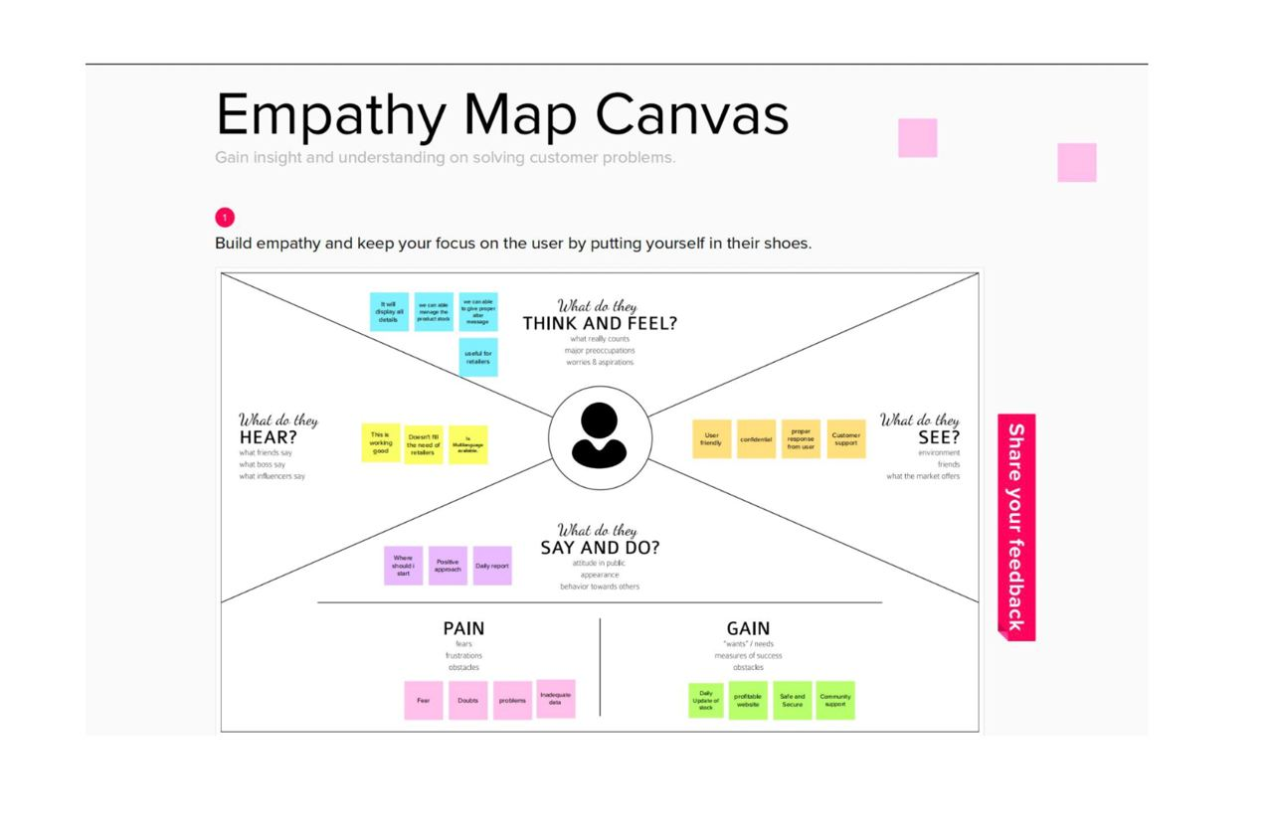

**3.2 IDEATION AND BRAINSTORMING**

The Ideation and Brainstorming is done in such a way that the whole project works well and good. The overall ideation is to know about the functionalities that we need for the Inventory Management System. The Brainstorming also does the samething. So, By using Django and MySQLLite, we can use combined version for the Django Web Application, whoch can be further deployed into the cloud. Initially the project and app is created. And, for a further move, many more views and urls are created. All these views are given with a template and coloured. Further static files are if needed. At the end, Its Hosted in Local, and Cloud.

**3.3 Proposed Solution**

|  |  |  |
| --- | --- | --- |
| **S.No.** | **Parameter** | **Description** |
| **1.** | Problem Statement (Problem to be solved) | * Retailers are unable to keep a track on the stock availability. * They cannot ensure whether the product is expired or not. * They do not have any system to record the inventory data. |
| **2.** | Idea / Solution description | * This proposed system will have a daily update of stock * The system will have an alert message to indicate stock availability. * The system will give alert for the stock which is less than the threshold limit * Customers can register their accounts then they will be given login credentials and they can use to place order. * Tracking the order has become easy with this application for both the retailers and the customers. |
| **3.** | Novelty / Uniqueness | * The retailer can get alert message when the stock gets over. * Demand based advanced stock pre order. * We can include a prediction of stocks to guess which will be the most purchased stocks so that the retailers can restock up on that prior. * We can also make maintenance and development easier by containerizing via Docker application.. |
| **4.** | Social Impact / Customer Satisfaction | * Customer Satisfaction is entirely depended on the service provide by retailers. * The available stock will be displayed so searching time will be saved for customer. * The stock updated automatically so the work of the retailer will be reduced. * The customer will be satisfied by getting the proper response from the retailer. |
| **5.** | Business Model (Revenue Model) | * With better inventory management system we can provide robust and most reliable inventory management system. * Can deploy the most appropriate business advertising models. * Loss prevention strategy is established * Usage of freebies business strategy for dragging the customer’s attention |
| **6.** | Scalability of the Solution | * With the use of IBM cloud infrastructure our proposed model will be able to handle a large number of user data. * Also to create a scalable inventory management the retailer have to keep a eye on system projections * Virtual machines that we use in IBM cloud are highly flexible and scalable. |

**3.4 PROBLEM SOLUTION FIT**

The issue-solution model Fit simply implies that you have identified a customer-related issue and that the resolution you have developed genuinely addresses the issue. It assists business owners, marketers, and corporate innovators in seeing behavioural trends and understanding what would be successful and why.Adapt your approach to complicated problem-solving to the needs of your consumers. By utilising current platforms and channels for behaviour, you may achieve success more quickly and boost solution acceptance. By using the appropriate triggers and message, you may improve your communication and marketing approach. By identifying the ideal problem-behavior fit and fostering trust by resolving persistent annoyances, pressing issues, or expensive difficulties, you may increase touchpoints with your business.In order to make things better for your target group, you must understand the current condition.

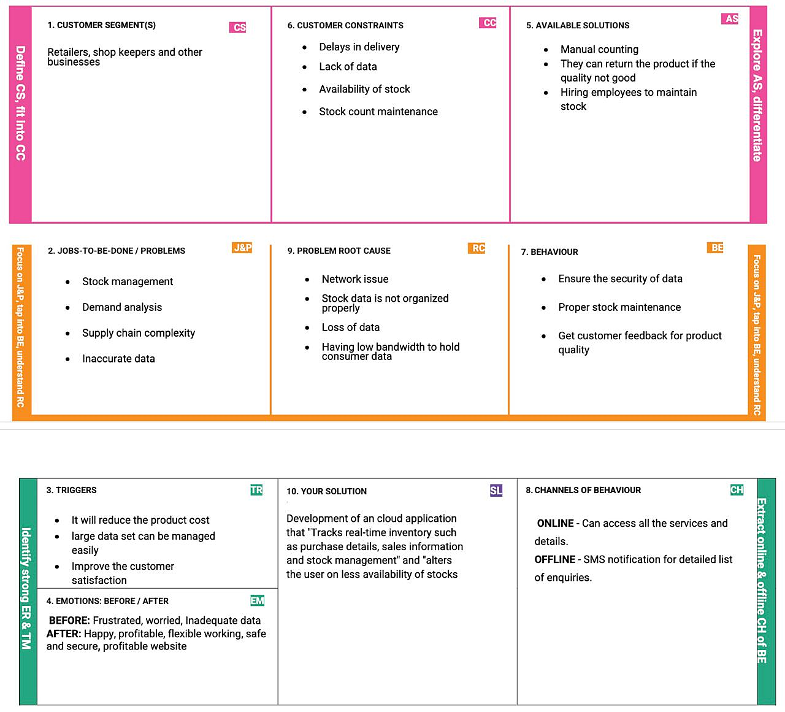

**4. REQUIREMENT ANALYSIS**

**4.1 Functional requirement**

Following are the functional requirements of the proposed solution.

|  |  |  |
| --- | --- | --- |
| **FR**  **No.** | **Functional Requirement(Epic)** | **Sub Requirement (Story / Sub-Task)** |
| FR-1 | User Registration | Registration through FormRegistration  through Email |
| FR-2 | User Confirmation | Confirmation via  EmailConfirmation via OTP |
| FR-3 | Login | Log into the application by entering theEmail and Password |
| FR-4 | Dashboard | View the stock availability |
| FR-5 | Add items to cart | They can add product to the cart is they wish to buy. |
| FR-6 | Stock Update | If the product is unavailable, they can add it to Wishlist. |
| FR-7 | Records of the products | Product name Product category Product I’d Stock Count  Vendor details |
| FR-8 | Unavailability Alert | Alert Message through mail or phone number. |

**4.2 Non-Functional requirements**

Following are the non-functional requirements of the proposed solution.

|  |  |  |
| --- | --- | --- |
| **NFR No.** | **Non-Functional Requirement** | **Description** |
| NFR-1 | **Usability** | * Once retailers successfully log in to the application they can update their inventory details, also users will be able to add new stock by submitting essential details related to the stock. * They can view details of the current inventory. * The System will automatically send an email alert to the retailers if there is no stock found in their accounts. So that they can order new stock. * It can use by wide variety of client as it is very simple to learn and not complex to proceed   Easy to use, User-friendly and Responsive |
| NFR-2 | **Security** | * Applications have been developed to help retailers track and manage stocks related to their own products. The System will ask retailers to create their accounts by providing essential details. * Retailers can access their accounts by logging into the application. * With Registered Mail id only retailers can log into the application.   We are using login for the user ansd the information will be hashed so that it will be very secure to use. |
| NFR-3 | **Reliability** | It will be reliable that it can update with very time period so that the accuracy will be good. |
| NFR-4 | **Performance** | * User can track the record of goods * Inventory tracking helps to improve inventory management and ensures that having optimal stock available to fulfill orders. * Reduces manpower, safe and secure . * Emails will be sent automatically When stocks are not available. * Makes the business process more efficient.   Improves organizations performance. |
| NFR-5 | **Availability** | * The availability of product is just one way in which an inventory management system creates customer satisfaction.   Inventory management systems are designed to monitor product availability, determine purchasing schedules for better customer interaction.   * Prediction will be available for every user but   only for premium user news, database and  price alert will be alert |
| NFR-6 | **Scalability** | * They should use an automated inventory management system for inventory tracking. * This will make your business much more scalable so that you can continue building consistent growth and take advantage of increased sales. |

**5. PROJECT DESIGN**

**5.1 DATA FLOW DIAGRAMS**

A Data Flow Diagram (DFD) is a traditional visual representation of the information flows within a system. A neat and clear DFD can depict the right amount of the system requirement graphically. It shows how data enters and leaves the system, what changes the information, and where data is stored.

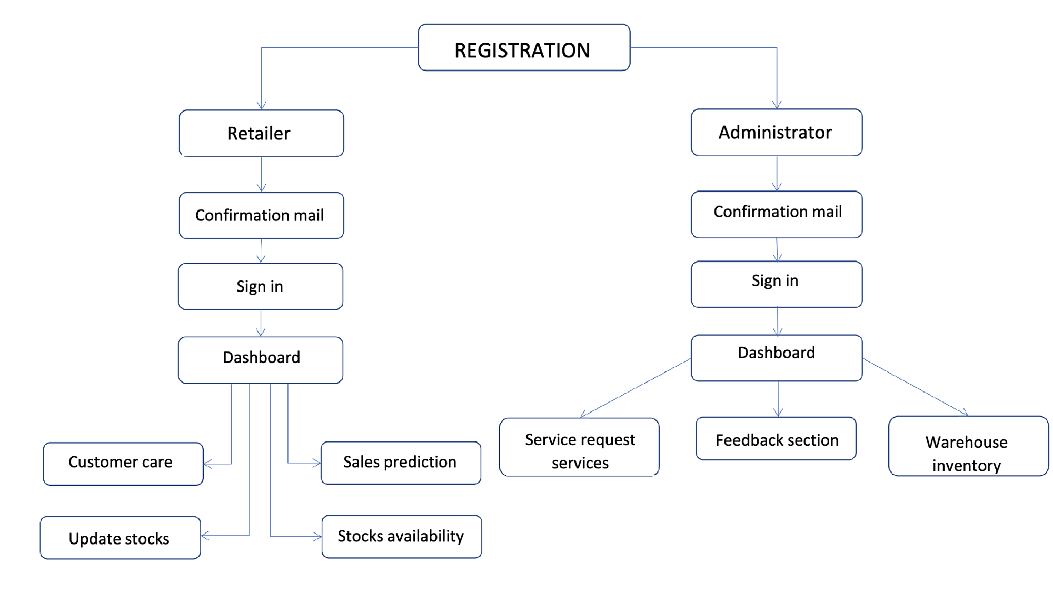

**5.2 SOLUTION & TECHNICAL ARCHITECTURE**

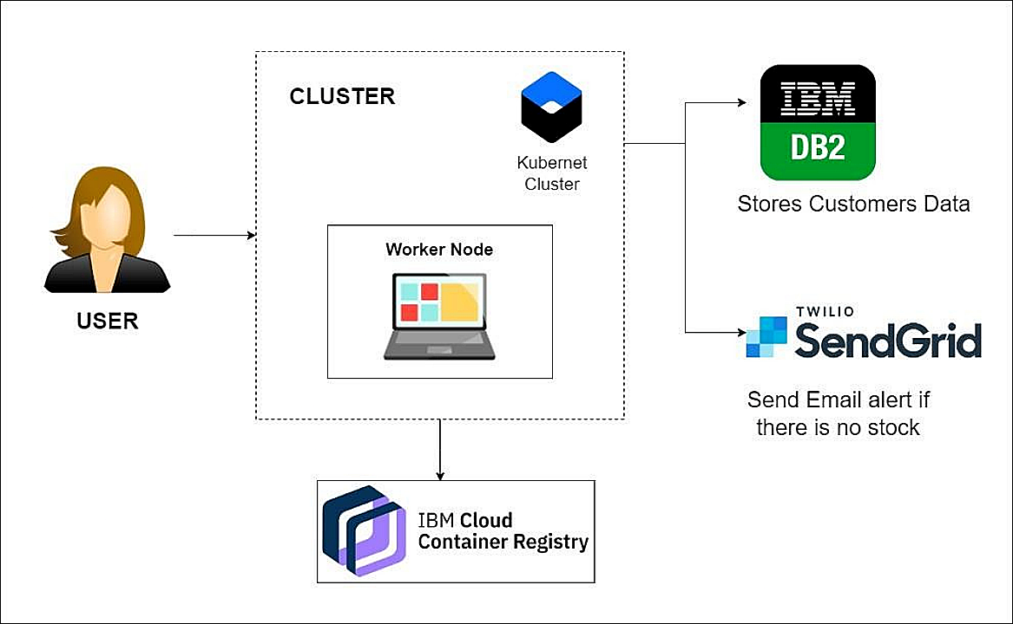

**APPLICATION CHARACTERISTICS:**

|  |  |  |  |
| --- | --- | --- | --- |
| **S.NO** | **COMPONENT** | **DESCRIPTION** | **TECHNOLOGY** |
| 1. | User Interface | Information processed will be sent to the user as a mail through web application | HTML, CSS, JQuery, JS,  Python, etc. |
| 2. | Application Logic-1 | User registration through form and confirmation will be sent to the user via email. | Django, SendGrid |
| 3. | Application Logic-2 | Dashboard is used to track the sales of product and inventory levels. | Django |
| 4. | Application Logic-3 | User will get notified about the realtime stock status | Django |
| 5. | Database | The data can be stored in a database and the user can retrieve or manipulate the data anytime | IBM DB2. |
| 6. | Cloud Database | Information of the stocks will be stored and hosted on the cloud | IBM DB2. |
| 7. | File Storage | Requirements to store files | IBM Block Storage or Other Storage Serviceor Local File  system |
| 8. | External API-1 | SendGrid used in application will send the email alert if there is less number or no stock to the user in real time | SendGrid |
| 9. | External API-2 | IBM container Registry enables you to store and distribute Docker images in a managed private registry | IBM container registry |
| 10. | Infrastructure (Server/Cloud) | Application Deployment on Local System / CloudLocal Server Configuration:localhost:5001(Django) Cloud Server Configuration : Kubernetes | Local, Cloud Foundry,Kubernetes, etc. |

**COMPONENTS & TECHNOLOGIES:**

|  |  |  |  |
| --- | --- | --- | --- |
| **S.NO** | **CHARACTERISTICS** | **DESCRIPTION** | **TECHNOLOGY** |
| 1. | Open-Source Frameworks | SendGrid will send email alerts, if there is less stock to the user, Kubernetes for manipulating Kubernetes API objects, IBM DB2 is used for storing and retrieving the data efficiently. | Django, SendGrid, IBMDB2,  Kubernetes |
| 2. | Security Implementations | We use login for the user and the information will be hashed so that it willbe very secure to use. | IBM container registry |
| 3. | Scalable Architecture | It is scalable that we are going to use data in kb so that the quiet amount of storage is satisfied. | Django |
| 4. | Availability | Prediction will be available for every user but only for premium user news, database and price alert will be alert | Django |
| 5. | Performance | It will perform fast and secure even atthe lower bandwidth | Django, IBM container registry, IBM DB2. |

**5.3 USER STORIES**

Use the below template to list all the user stories for the product.

|  |  |  |  |  |  |  |
| --- | --- | --- | --- | --- | --- | --- |
| **User Type** | **Functional**  **Requirement (Epic)** | **User Story Number** | **User Story / Task** | **Acceptance criteria** | **Priority** | **Release** |
| Customer (Web user) | Registration | USN-1 | User can register for the application byentering my email, password, and confirming  my password. | User can access my account /dashboard | High | Sprint-1 |
|  |  | USN-2 | User can login through my E-mail | User can access my account /dashboard | Medium | Sprint-1 |
|  | Confirmation | USN-3 | User can receive my confirmation emailonce I have registered for the application | User can get confirmation email for my account and create an authenticated  account. | Medium | Sprint-1 |
|  | Login | USN-4 | User can log in to the authorized account by entering the registered email and  password | User can login with registered email and password. | High | Sprint-1 |
|  | Dashboard | USN-5 | User can view the products that are available currently. | Inventory can be viewed once logged in. | High | Sprint-2 |
|  | Stocks update | USN-6 | User can add products which are not available in the inventory and restock the products. | When the products are not available, retailers can restock and update their inventory. | Medium | Sprint-2 |
|  | Sales prediction | USN-7 | User can get access to sales prediction tool which can help me to predict better restock management of product. | The sales prediction tool should forecast the sales so that the users can order properly and retailers can  predict the order to sell. | Low | Sprint-3 |
| Administrator | Request for customer care | USN-8 | User am able to request customer care to get in touch with the administrators and enquire the doubts and problems. | User can contact customer support and get  help and service from administrators. | Medium | Sprint-4 |
|  | Giving feedback | USN-9 | User am able to send feedback forms reporting any ideas for improving or resolvingany issues I am facing to get it resolved. | User can give feedback of issues or improvements to the administrators. | Medium | Sprint-4 |

**6. PROJECT PLANNING & SCHEDULING**

**6.1 SPRINT PLANNING & ESTIMATION**

Use the below template to create product backlog and sprint schedule

|  |  |  |  |  |  |  |
| --- | --- | --- | --- | --- | --- | --- |
| **Sprint** | **Functional Requirement (Epic)** | **User Story Number** | **User Story / Task** | **Story Points** | **Priority** | **Team Members** |
| Sprint-1 | Registration | USN-1 | User can register for the application by using my email & password and confirming mylogin credentials. | 3 | High | Danush P S  Praveen Babu R Shalinisri J Kavipriyaa P |
| Sprint-1 |  | USN-2 | User can login through my E-mail. | 3 | Medium | Danush P S  Praveen Babu R Shalinisri J Kavipriyaa P |
| Sprint-1 | Confirmation | USN-3 | User can receive my confirmation emailonce I have registered for the application. | 2 | High | Danush P S  Praveen Babu R  Shalinisri J Kavipriyaa P |
| Sprint-1 | Login | USN-4 | User can log in to the authorized account by entering the registered email and password. | 3 | Medium | Danush P S  Praveen Babu R Shalinisri J Kavipriyaa P |

|  |  |  |  |  |  |  |
| --- | --- | --- | --- | --- | --- | --- |
| Sprint-2 | Dashboard | USN-5 | User can view the products that are available currently. | 4 | High | Danush P S Praveen Babu R Shalinisri J Kavipriyaa P |
| Sprint-2 | Stocks update | USN-6 | User can add products which are not available in the inventory and restock the products. | 3 | Medium | Danush P S Praveen Babu R Shalinisri J Kavipriyaa P |
| Sprint-3 | Sales prediction | USN-7 | User can get access to sales prediction tool which can help me to predict better restock management of product. | 6 | Medium | Danush P S Praveen Babu R Shalinisri J Kavipriyaa P |
| Sprint-4 | Request for customer care | USN-8 | User can able to request customer careto get in touch with the administrators and enquire the doubts and problems. | 4 | Medium | Danush P S Praveen Babu R Shalinisri J Kavipriyaa P |
| Sprint-4 | Giving feedback | USN-9 | User can able to send feedback forms reporting any ideas for improving or resolving any issues I am facing to get it resolved. | 3 | Medium | Danush P S Praveen Babu R Shalinisri J Kavipriyaa P |

**6.2 SPRINT DELIVERY SCHEDULE**

|  |  |  |  |  |  |  |
| --- | --- | --- | --- | --- | --- | --- |
| **Sprint** | **Total Story Points** | **Duration** | **Sprint Start Date** | **Sprint End Date (Planned)** | **Story Points**  **Completed (as on Planned End Date)** | **Sprint Release Date (Actual)** |
| Sprint-1 | 11 | 4 Days | 03 Nov 2022 | 06 Nov 2022 | 11 | 06 Nov 2022 |
| Sprint-2 | 7 | 4 Days | 07 Nov 2022 | 10 Nov 2022 | 7 | 10 Nov 2022 |
| Sprint-3 | 6 | 4 Days | 11 Nov 2022 | 14 Nov 2022 | 6 | 14 Nov 2022 |
| Sprint-4 | 7 | 4 Days | 15 Nov 2022 | 18 Nov 2022 | 7 | 18 Nov 2022 |

**7. CODING & SOLUTIONING**

**7.1 REGISTER AND LOGIN**

Registration allows the user to create new account and enjoys the functionality of the website. It is mandatory for everyone to create their own account before getting their Inventory. The user's name, email and password is collected from the user for registering them into the website. Once the users successfully got registered, they could login using their Username and password.

**7.2 ADD STOCK**

Add stock allows the user to add the newly available stocks to his/her Inventory / Warehouse. It is an optional one. But, some other views will work only if we have some stock in our warehouse. One can add the product name, number of stocks, price and tax of the product. Once the user add their stock they could see the lastly added stock in their Home page and View Stock page as well.

**7.3 VIEW STOCK**

View stock allows the user to view the existing products/ stocks that are available in the inventory/ warehouse. It will show the table of contents in a table format.

**7.4 REMOVE STOCK**

Remove Stock allows the user to remove the products/ stocks that are available in the inventory/warehouse. It has two fields in it. A select option to remove. Number of Stocks to be removed. If there are any wrong entry, the system will automatically throw an error.

**7.5 ADMIN**

This Panel is very specific to Admin. This is a automatic Django Administration Panel. Everyone who register into the system will not get the access for it. The Admin should provide the access. Also, the Admin access to all the users and stocks that are available.

**7.6 DATABASE SCHEMA**

There are 2 models that are specifically used in this system. One is to store the users and another is to store the stocks that are added.

* User - It stores the details of all registered user. It helps during the process of login and registration.
* Stock - It stores the details of all stocks that are added. It's helpful in viewing and removing the stocks.

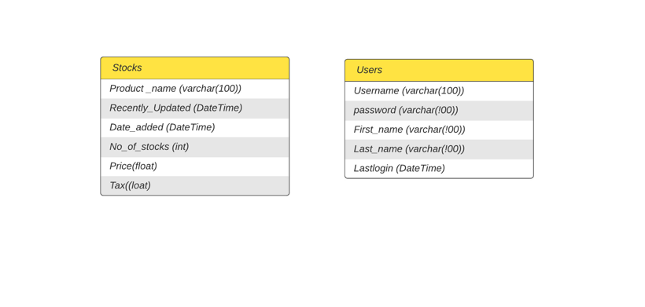

**8.TESTING**

**8.1 TEST CASES**

The Testcase is basically perfomed by adding multiples stocks and deleting users as well.

The test cases are users and stock informations

**8.2 USER ACCEPTANCE TESTING**

The List of users of given to the registeration and checked whether the users are accepted or not.

**9. RESULTS**

**9.1 PERFORMANCE METRICS**

The performance metrics are acheived and the screenshots of the system is attached as below.

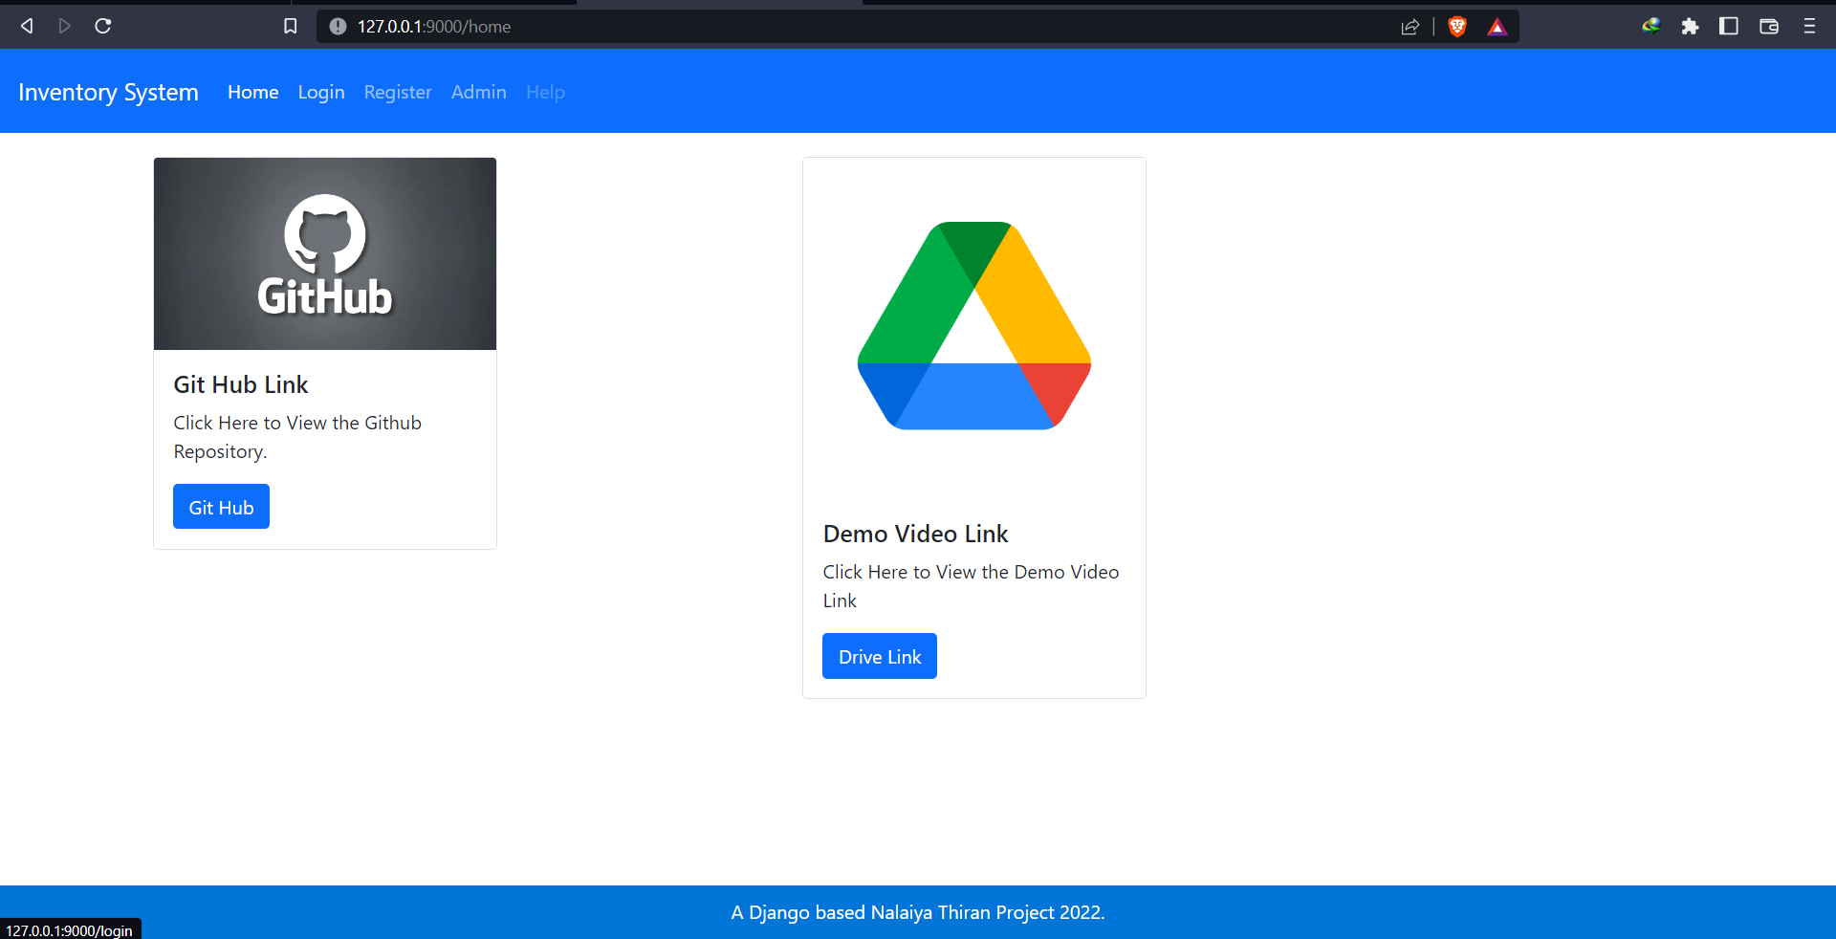

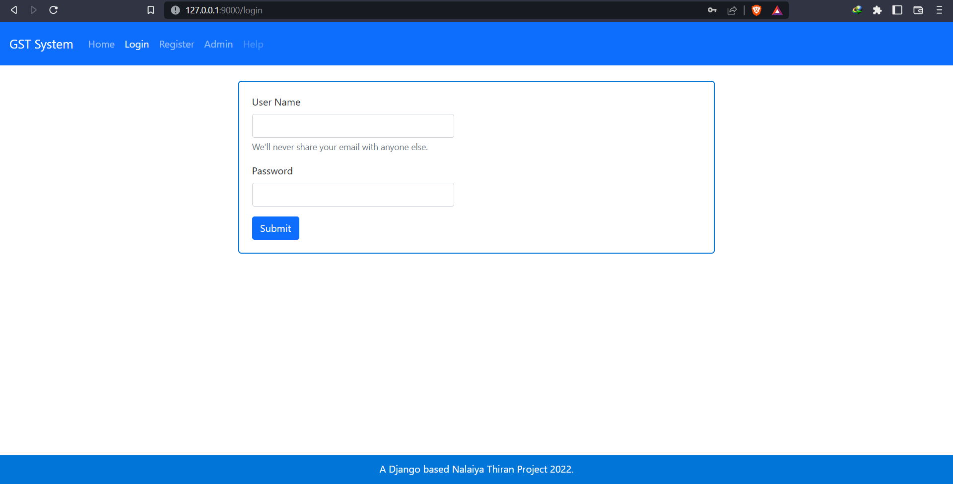

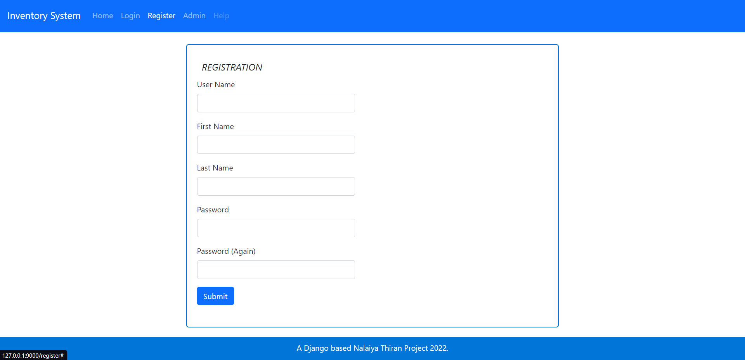

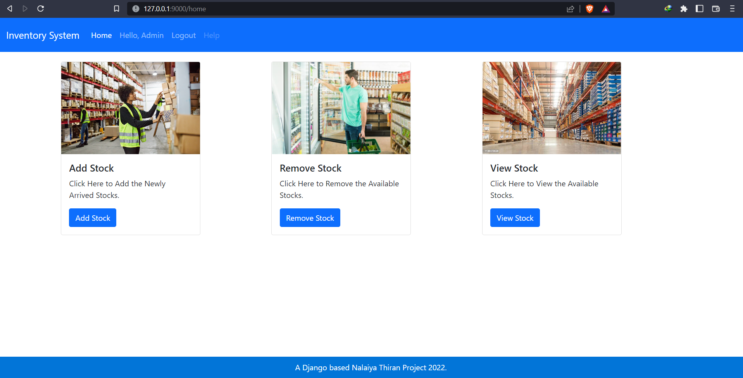

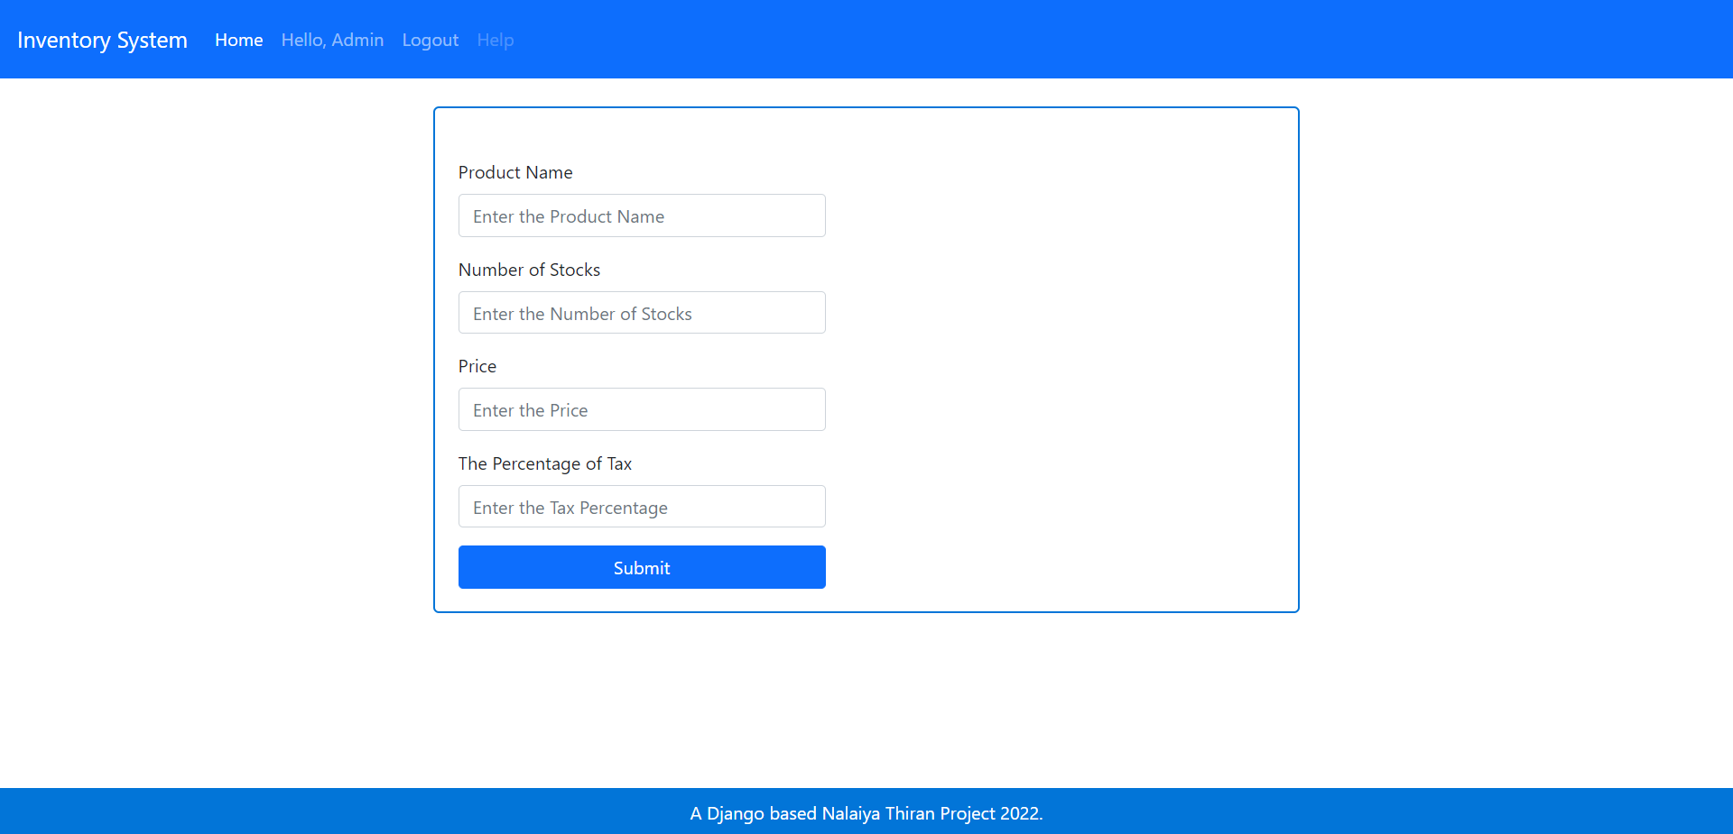

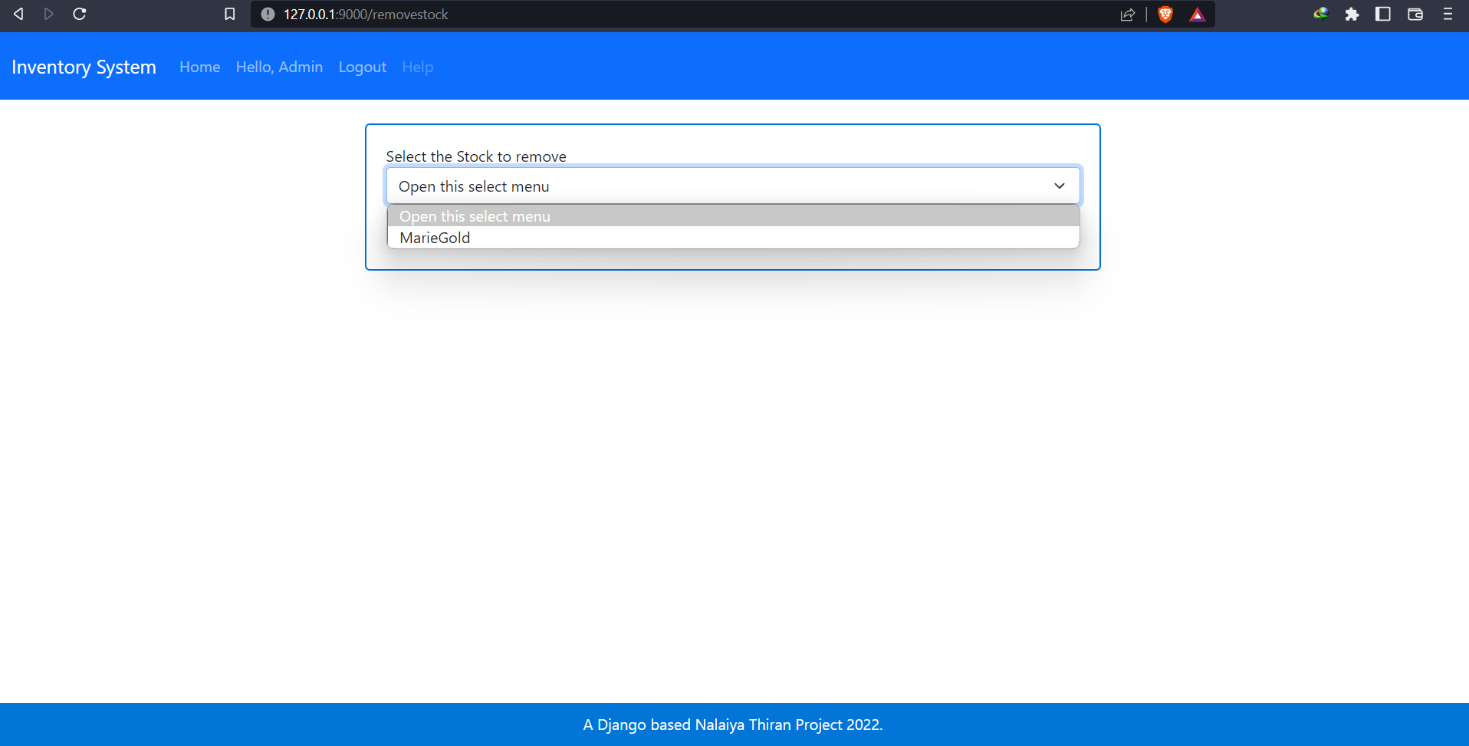

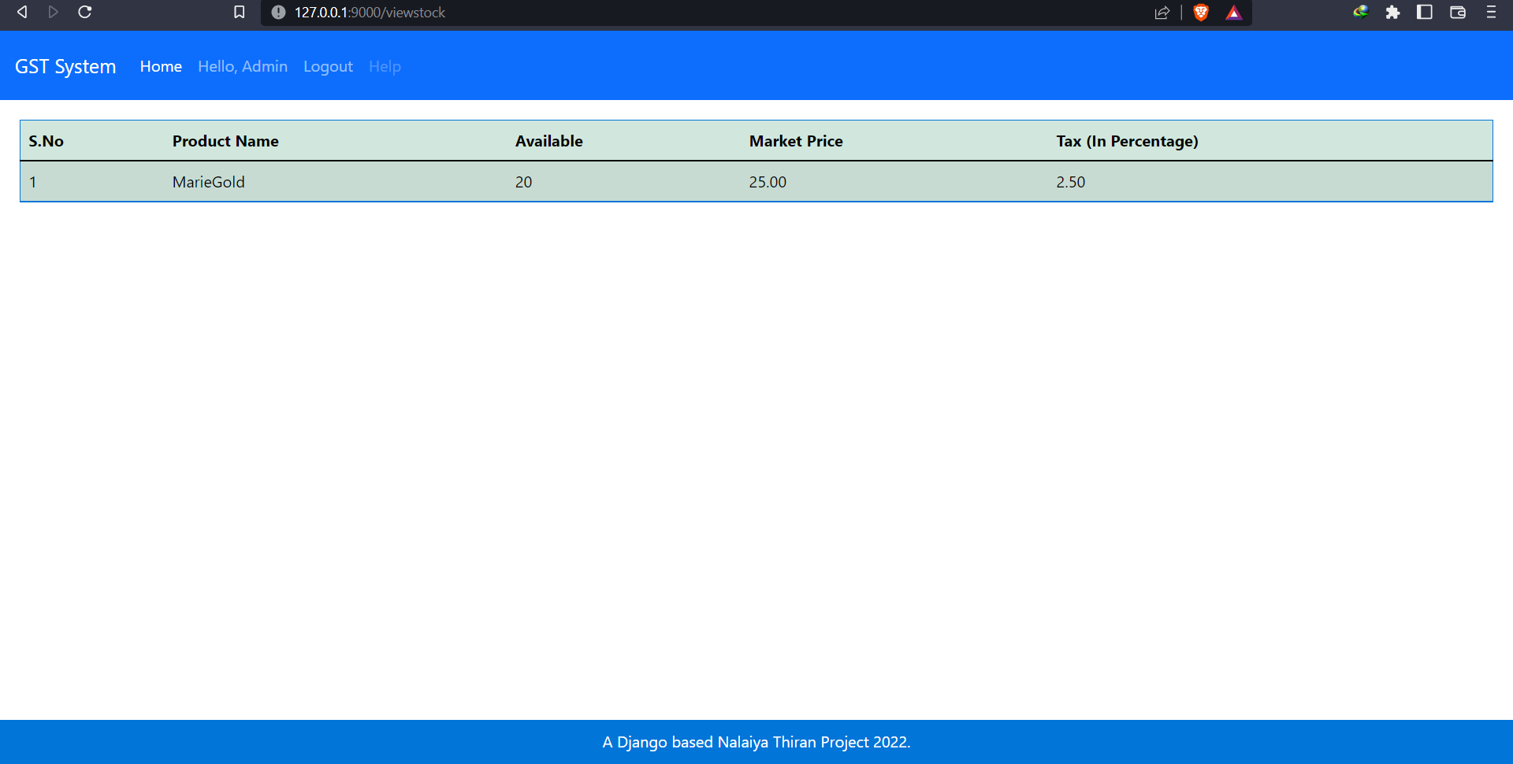

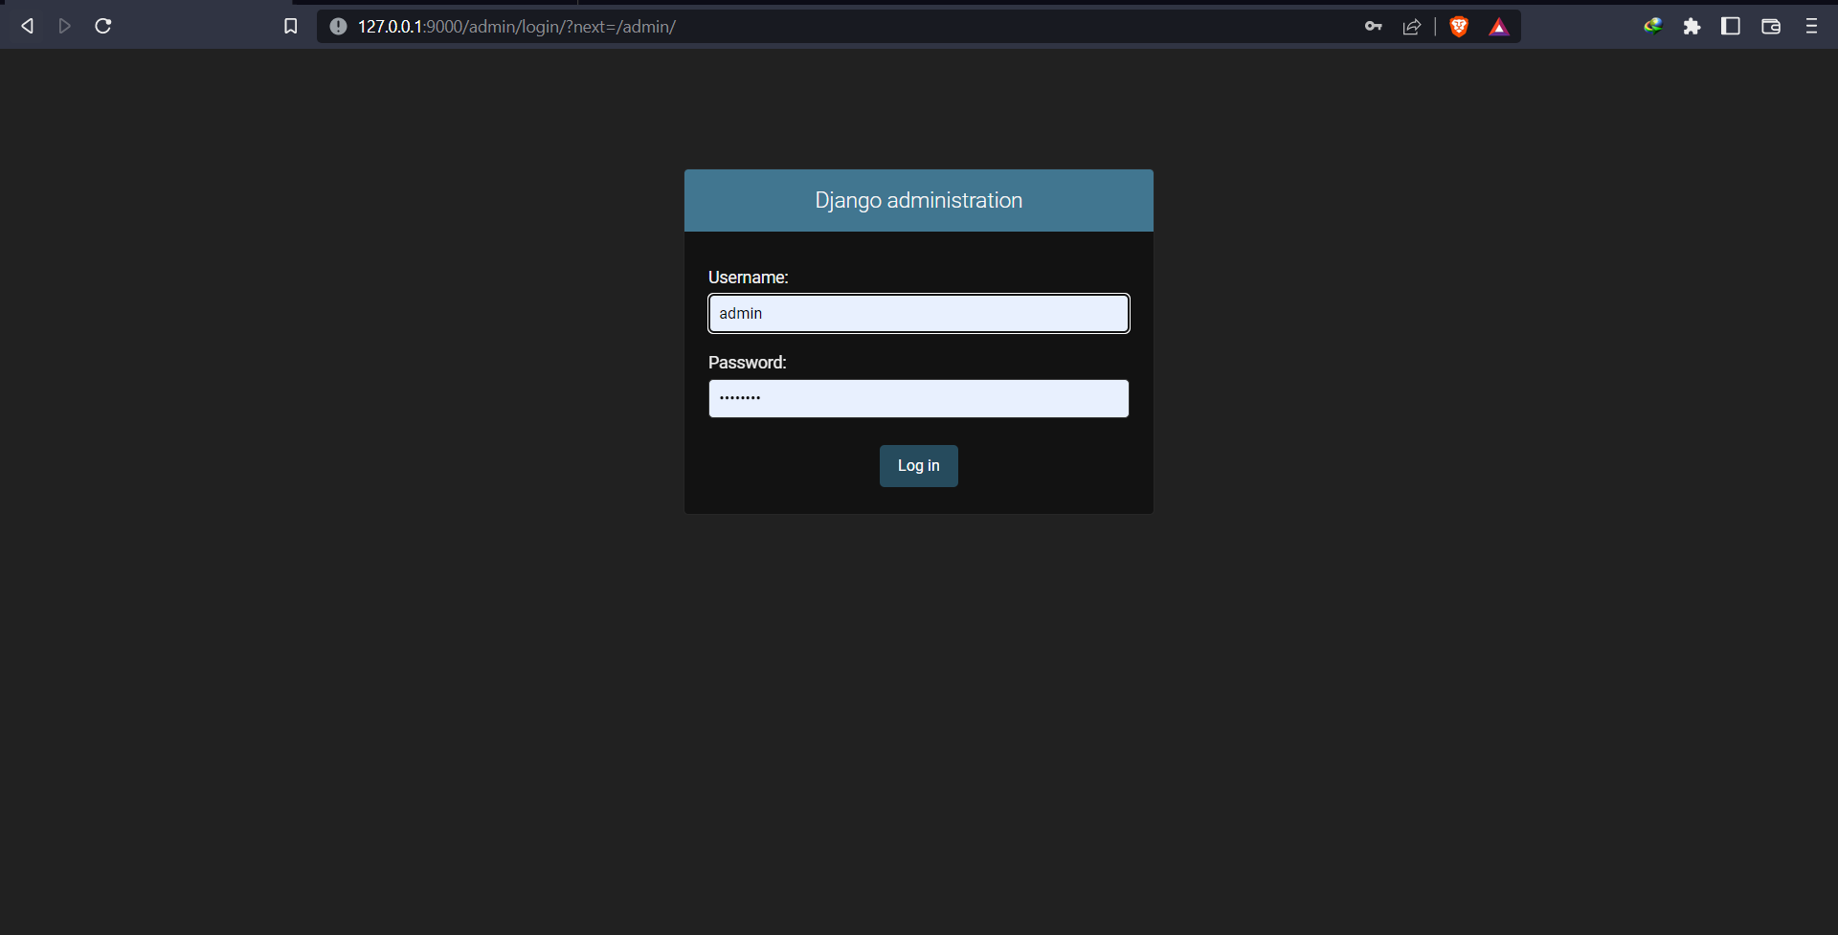

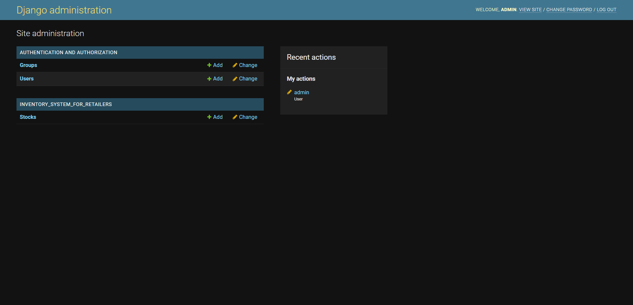

**10.ADVANTAGES & DISADVANTAGES**

The primary advantage of this who machine is Django. As It follows MVT, its very easy to add or move our templates according in accordance with the specific url's. And its really secured, as it uses django user interface to login and register.

The Disadvantage is less number of functionalities, there are some more functionalities that could be added as per our need. But, It could lack in that.

**11. CONCLUSION**

The retail market has a wide scope for e-bill systems. And this could help them in such a way that the billing and stock check would be so fast than before. As per digitalization, This could be a start of it in local shops too.

**12. FUTURE SCOPE**

The future scope is very wider for this system. Whomever wishes can add any feature or functionality that they want, and that would work out so well in this project. For a better UI/UX and readability, one can look on UX changes. Also, We can add some ML Algorithms to predict the removed or added products in the stocks.

**13. APPENDIX**

**SOURE CODE WITH GITHUB LINK:**

[**https://github.com/IBM-EPBL/IBM-Project-5938-1658820412**](https://github.com/IBM-EPBL/IBM-Project-5938-1658820412)

**PROJECT DEMO LINK:**

[**https://drive.google.com/file/d/1los54hihyassqpxodFGDFJHEZ4wHTnL6/view?usp=share_link**](https://drive.google.com/file/d/1los54hihyassqpxodFGDFJHEZ4wHTnL6/view?usp=share_link)